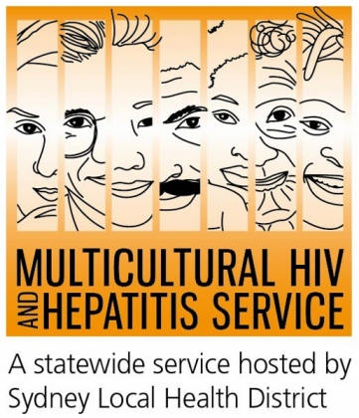


2019 HIV Testing Week

New emoji video encourages HIV testing
A new emoji video is encouraging testing this HIV Testing Week (1-7 June). Produced by Pozhet NSW in collaboration with the Multicultural HIV and Hepatitis Service (MHAHS), the Never tested for HIV? video features a popular digital icon asking people if they had been tested for HIV.
Emojis are a simple and fun way to connect with others, according to Natali Smud, Senior Health Promotion Officer at the MHAHS.
“By adding the emoji to the video, we hope to inspire people to share the information and spark a conversation about HIV testing. HIV testing is easy and private. Get tested today,” said Natali Smud.
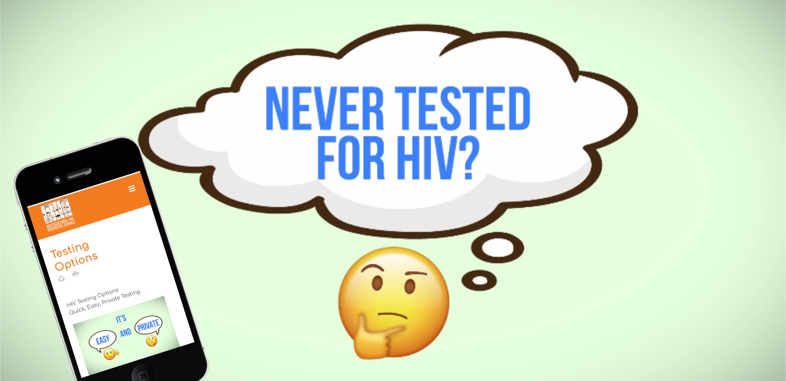
The video is further complemented by a new “Testing Options” web page on the MHAHS website detailing HIV testing services including anonymous services and those not requiring a Medicare card.
“Lack of health information makes people vulnerable. By addressing the needs of disadvantaged groups, the Testing Options web page reduces health disparities by increasing access to vital HIV testing and care,” said Natali Smud.
Raising awareness of HIV testing is an important element of NSW goal to eliminate HIV transmission, according to Wael Sabri, Senior Community Engagement Officer, coordinator of the International Student Project at the MHAHS.
“One in ten Australians living with HIV are unaware of their situation, and so testing is vital in stopping the spread of HIV. Once people are diagnosed we have very effective treatments, so they are able to just get on with life,” said Mr Sabri.
“There are many safe ways of getting HIV test. Testing at home by ordering a Dried Blood Spot test kit has been available for the past few years. Fast-track “Express” clinics, after hours appointments, and peer-led community-based testing clinics for men who have sex with men are all part of the new era in HIV testing in NSW. People can also request a test at their family doctors,” said Mr Sabri.
-END
For radio interviews, please contact Sonam Paljor at 02-95151234 or email sonam.paljor@health.nsw.gov.au

